Earl Mortimer College
Mobile Telephones Policy (Students)



Title of Policy | Mobile Telephones Policy (Students)
Policy Type | School
Review Cycle | 2 years
Prepared By | Julian Wharam
Committee Responsible | Student Wellbeing & Community
Date of Review | 03 February 2026
Date of Submission to FGB | 10 March 2026
Date of Next Review | 3rd February 2027

Aim
We strive to create a school culture where students are able to fully apply themselves to their learning. Students must feel safe if they are to learn effectively. At Earl Mortimer College a key priority is to safeguard our students and their mental health and wellbeing.
The use of mobile phones is of particular importance with the advent of increasingly sophisticated technology that allows the capture and distribution of images, videos and sounds. Mobile phones present a number of challenges that can impact upon health and wellbeing, including:

- The potential loss of a valuable item through theft.

- Unwelcome peer pressure associated with the ownership of phones offering the latest technology.

- The use of phones to carry out or support bullying.

- The potential use of mobiles phones in classrooms and the associated disruption to teaching and learning.

- The use of integrated camera technology in relation to potential child protection or data protection issues.

- The contacting of a parent/carer by a student involved in a discipline related issue prior to the school having the opportunity to respond to, or fully investigate the matter.

To support students in complying with the phone-free school policy, all students are expected to use a Yondr pouch to store their phone during the school day (this is inclusive of all times they are on school site, from entrance in the morning to leaving either at the end of the school day or an after-school activity or sport fixture).

Expectations
Earl Mortimer College is a phone-free school. Mobile phones are not to be used by students during the school day. Every student is assigned a personal Yondr wallet free of charge. While the Yondr wallet remains the property of the school, it is the responsibility of each student to bring their wallet with them to school every day and to keep it in good working condition.

Daily Process
As students arrive to school, they will:
1) Turn their mobile phone off.
2) Open their Yondr pouch by tapping it against the unlocking base at their entrance.
3) Place their mobile phone inside the wallet and secure it in front of school staff.
4) Store it in their school bag for the day.

As students leave school they will release their phone from the wallet by tapping it against the unlocking base. They will put their pouch into the school bag ready for use the next day.

Students bringing a mobile phone to school must bring their wallet to school with them each day.

Students arriving late or leaving early can access the unlocking base by going to Reception.

Violations

Wallet damage / lost wallet / using mobile phone during school
If a student damages their wallet school staff will call home to inform parents/carers and a fee of £5 will be charged via ParentPay for a replacement wallet.

Note: Damage consists of any signs that the physical integrity of the wallet has been compromised, whether intentional or unintentional, as determined by the school or Yondr staff.

Examples of damage:
● Ripped fabric
● Cut
● Torn
● Signs of force to black button on flap

If a student loses their wallet parents/carers a fee of £5 will be charged via ParentPay for a replacement wallet.

If a student informs school staff they have not brought a mobile phone to school, school staff may call home to verify this is the case.

If a student is found with their phone not secured in their wallet during the school day, school staff will confiscate the mobile phone and call home. This will be viewed as wilful noncompliance with school policy. In this instance a parent or carer will need to come into school to collect the phone and the student will serve a detention in line with the school’s behaviour policy.

Forgotten Wallet

If a student forgets their Wallet, their mobile phone will be collected and school staff will call home to remind the Parent/Carer of the policy.

The phone will be returned to the student at dismissal at the end of the school day.

If a student consistently forgets their wallet, it is considered lost. Refer to the Lost Pouch policy above.

Staff

Staff are expected to model the behaviours we expect from our students. Staff are expected to not to use their phone during the working day for personal use. However, due to the nature of our large site and duties staff perform, some staff will require the use of a mobile phone during the day for safeguarding purposes.

How Yondr works

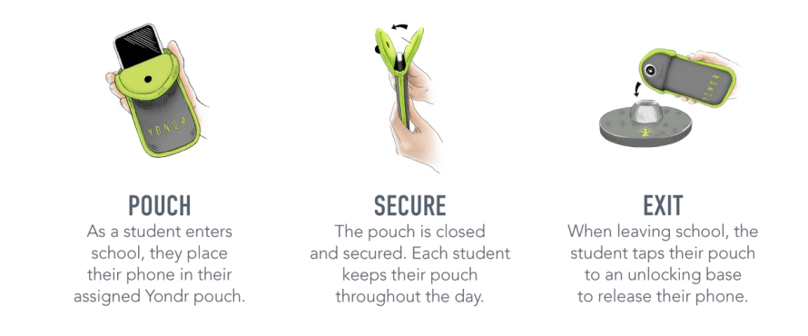

Monitoring

The Senior Leadership Team, Heads of House and form tutors will monitor the frequency of violations and sanctions.

This policy needs to be read in connection with:
● Behaviour policy
● Keeping children safe in education 2022 statutory guidance

